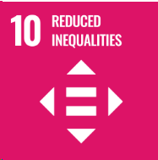
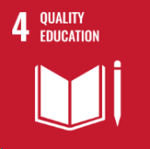
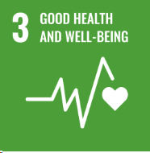
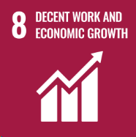
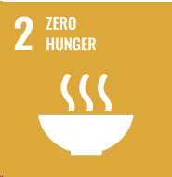
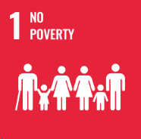
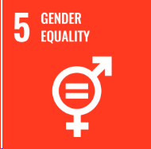
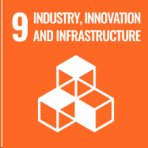
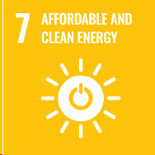
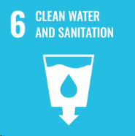

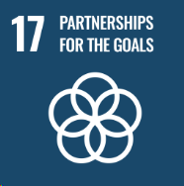
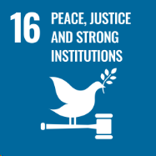
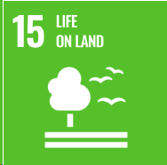
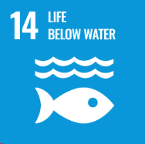
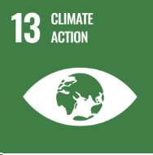
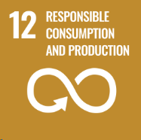
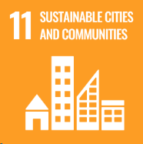
- Various bylaws enabling management of stormwater, trade waste and wastewater
- Upgrade of wastewater treatment plants in Raglan, Whangamarino and Ngaaruawaahia
- Adoption of the Northern Hamilton-Waikato Metropolitan Detailed Wastewater Business Case
- Maaori ward Councillors
- Undertaking continual Community engagement (workshops, open days)
- Fraud Prevention Policy
- Conflict of Interest Policy
- Whilst no specific work has been able to be identified in relation to this, a lot of the work currently being undertaking impacts on the reduction of inequalities and providing equality of opportunity for all
- Climate Response and Resilience Strategy
- Climate Action Plan (Community and Operational)
- Climate Response and Resilience Policy
- State of Environment Reporting
- Cyclone Gabrielle Recovery Plan
- Development of a Marae Resilience Strategy
- 5% reduction in operational emissions, 8% reduction in district emissions (2023)
- 66% of Councils fleet either hybrid or plug-in hybrid
- Waikato District Resilience Project
- Undertaking Climate Risk Assessment
- Embedding of ‘Climate Action’
- Staff Sustainability workshops
- Development of Climate Change Principles
- Reflected in Council’s key land use planning documents such as Waikato 2070 and district plans, Housing Strategy, enabling of Papakaainga
- Blueprints
- Taupiri, Hopuhopu and Ngaaruawaahia Structure Plans and Ngaaruawaahia Town Centre Plan
- Improvements to micro-mobility transport in Huntly using $1.9 million from Climate Emergency Response Fund
- Enabling further housing via Variation 3 Enabling Housing Supply
- Bringing to life the Taiao (Nature) in the Waikato Strategy
- Planting of over 31,000 native plants across the district (2022 calendar year)

- Support of the Waikato Tourism Ambassador Programme in the Waikato District
- Establishment of Rural Economic Advisory Panel
- Sustainable Procurement Programme
- Business Networking Events
- Supporting various initiatives through Community-led development
- Internally:
- Safety Action team
- Vitae Services for staff
- Wellbeing collective
- Work Safe Home Safe
- Safety Conversations
- Zero Harm Commitment
- ERoad
- Applying the National Policy Statement for Highly Productive Land (NPS-HPL) via the District Plan
- Whaingaroa, Ngaruawahia and Raahui Pookeka Collective- creation of new and enhancement of existing Maara kai Community Gardens
- Working in partnership regarding the Waikato River settlement (JMA)
- Waipa River JMA with Te Nehenehenui Trust
- MoU with Ngaa Uri o Maahanga
- Iwi and mana whenua engagement across a range of issues/areas
- Adoption of the Waikato-Tainui | Waikato District Council Strategic Work programme
- Partnering with Community Groups
- Futureproof partnership to support cross-boundary land use and infrastructure planning.
- Bringing to life Taiao (Nature) in the Waikato Strategy
- Wharekawa Coast 2120 Community Plan
- Waste Management and Minimisation Plan
- Waste Audits
- Diversion of 36% of Waste from landfill
- Upgrades to recycling drop off centres
- Continual reporting on Annual CO₂e Inventory (operational)
- Support to Xtreme Zero Waste
- New recycling sorting facility in Huntly
- Fast tracking of consents for Solar and Wind farms, e.g. Waiuku
- Removal of gas boiler at Huntly Aquatic centre (reduced Council’s corporate emissions by around 14%)

This goal is impacted by action across the other 16 goals, e.g. Housing Strategy (under SDG 11) providing more housing for those in need
- Working alongside mana whenua and upholding Te Ture Whaimana
- Collaborating with Taumata Arowai and uploading a stocktake of our drinking water supplies online portal.
- Participation in WRC water quality programme
- 9 Female Councillors (up from 6 in the previous Council)
- Increase in female managers/team leaders at WDC

- Waikato District Library Strategy
- Digital Libraries
- Library Community Outreach services
- Te Reo Maaori and Te Tiriti classes for staff
- Support to Enviroschools and Para Kore education programmes

