=\To | Mayor and Councillors
From | Hannah Beaven, Principal Corporate Planner  Tanya O’Shannessey, Monitoring Team Leader  Melissa Ward, Corporate Planner
Subject | Keeping of Animals Bylaw 2024
Date | 13 February 2024

Purpose of the workshop
Staff are seeking Council’s decision on a preferred option for defining our urban, lifestyle and rural areas for a proposed Keeping of Animals Bylaw 2024 (Attachment 1), and approval to undertake early engagement (Attachment 2) from 19 February to 31 March 2024.

Executive summary
Council’s 2015 Keeping of Animals Bylaw included rules for managing nuisance-related complaints around animals, other than dogs. Staff are proposing a new Keeping of Animals Bylaw. At a Council workshop on 21 November 2022, Council provided feedback on the proposed Bylaw. These changes have been made to the Bylaw (Attachment 1) as directed.

Staff seek from Council:

- A decision on the preferred approach for defining urban, lifestyle, and rural areas within a proposed Bylaw. These options are detailed below:

- Property size, as below:
- Urban: Up to and including 2,000 square metres.
- Lifestyle: 2,000 to 15,000 square metres.
- Rural: 15,000 square metres or larger.
- A combination of district plan zone and property size.
- District plans zones only (recommended by staff).
- Bespoke maps.

- Approval to undertake early engagement with the community and stakeholders, from 19 February to 31 March 2024. The proposed engagement material can be found in Attachment 2.

Background
Council’s 2015 Bylaw included rules for managing nuisance-related complaints around animals, other than dogs. Controls around responsible dog ownership are covered under the Dog Control Bylaw and Policy 2022. Staff have become aware that, due to the timing of the Council's review of the 2015 Bylaw in 2021, the 2015 Bylaw is now invalid. Staff are seeking to rectify this issue by drafting and adopting a new Keeping of Animals Bylaw (proposed Bylaw).

Please refer to Table 1 (below) to understand how the bylaw rules previously applied across the different areas.

Table 1: Examples showing how rules were in place throughout the Waikato district in the previous iteration of the bylaw.
Animal | Urban | Lifestyle | Rural
All animals | General nuisance rules apply across Urban, Lifestyle and Rural for all animals.
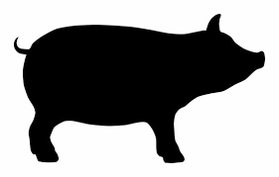 | No pigs. | Pigs allowed.  Pigstys must not be within 20m of dwellings or 30m from adjoining boundaries. | Pigs allowed.  Pigstys must not be within 20m of dwellings or 30m from adjoining boundaries.
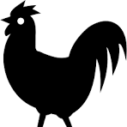 | No roosters. | No roosters in the ‘Country Living Zone’ from the Operative District Plan. | Roosters allowed.
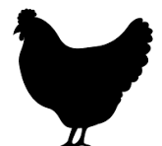    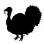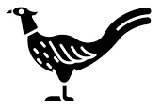  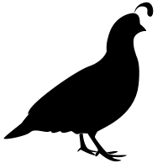 | Limits on poultry numbers.  Enclosed housing for poultry is required.  Poultry houses must be 10m away from buildings and 3m away from property boundaries.  Poultry includes chicken, ducks, geese, pigeons, turkeys, pheasants, quail and peacocks. | Poultry allowed.  Poultry houses must be 10m away from buildings and 3m away from property boundaries. | Poultry allowed.  Poultry houses must be 10m away from buildings and 3m away from property boundaries.
 | Limits on beehives:  Property area:  500-2000 square metres: 2 beehives  2001-4000 square metres: 4 beehives  4001 square metres +: 6 beehives  Beehives must be setback 3m (if there is a solid fence) or 5m (if there is no solid fence) from property boundary. | Limits on beehives in ‘Country Living Zone’ or ‘Rural Residential Zone’ from the Operative District Plan:  Property area:  500-2000 square metres: 2 beehives  2001-4000 square metres: 4 beehives  4001 square metres +: 6 beehives  Beehives must be setback 12m from the property boundary. | Unlimited number of beehives.  Beehives must be setback 25m from the property boundary.
 | Horses allowed, provided horses are kept by a registered breeder or in a stable. | Horses allowed. | Horses allowed.
 | The following rules apply to feral or stray animals (including cats) across the district:  - No one should offer support or shelter to a feral or stray cat so that the cat becomes a nuisance to others.  - If an animal causing a nuisance is identified as feral or stray, the property owner must take appropriate measures.

Staff from the Monitoring, Corporate Planning and Legal teams have reviewed the 2015 Bylaw (amended in 2021) and have proposed changes. At a Council workshop on 21 November 2023, further changes were made as directed by Council. Refer Table 2 for detail.

Table 2: Changes to Bylaw as directed by Council at 21 November 2023 workshop
Clause | Change made to bylaw | Rationale
1.0 | Include dates of Acts under the Introductory section. | To ensure the entire Act was included.
3.0 | Pigeon and quail were re-inserted into the definition of ‘Poultry’. ‘Breeding’ was also included as part of the definition of poultry. | Including pigeon and quail in the definition of ‘Poultry’ enables Council to address issues with pigeons or quail if these are present. Poultry can also be kept for breeding purposes, not just for producing eggs or meat for human consumption, as previously included in the Bylaw.
3.0 | A definition of property included. | To enable using property sizes to define urban, lifestyle and rural areas, outlined in Option 1.
5.0 | Clause 5.6 specifies that animals must be confined to the boundaries of the premises. An additional clause has been included explaining that this rule does not apply to cats, as below.  ‘Any person keeping an animal shall ensure the animal is confined to the boundaries of the premises where the animal is kept. This clause does not apply to cats.’ | This clause was not initially created to require cats to be constrained to their property. While cats may occasionally cause minor nuisance to neighbouring properties, imposing a strict limitation on their movement is deemed impractical.  Moreover, Council has only received four complaints about cats over the past five years, suggesting a relatively low level of concern.
7.0 | Remove the following set-back requirement for poultry houses, listed as Clause 7.5(a) ‘No poultry house (whether mobile or immobile), shall be located: a) within 10m from any dwelling, factory, or other building’. | This rule was deemed overly restrictive. Requiring a poultry house to be situated 10 meters away from a building poses a significant challenge for individuals aiming to keep poultry in urban areas.
7.0 | A timeframe included within Clause 7.8 ‘Any person, owner or occupier of a premises who receives a notice under clause 7.7 must should without delay comply with the notice within 14 days, or as it is considered reasonable by an authorised officer’. | A timeframe has been included to ensure compliance with the notice within a reasonable timeframe.
8.5 | Clause 8.5 amended to clarify that the limit to the number of beehives does not apply to properties located within the General Rural Zone or Rural Zone. | For clarity.

At the Council workshop, further information was requested in relation to the following areas. Staff responses are outlined in Table 3.

Table 3: Information requests from Council at workshop on 21 November 2023
Request | Staff response
- Staff to investigate if clause 9.2 (removal of horse excrement) aligns with rules in the Public Places Bylaw 2023. | - Staff have confirmed the proposed clauses in the Bylaw aligns with clauses in the Public Places Bylaw 2023.
- Concern the Tuakau Saleyard was listed as an exception to the Bylaw as complaints had been made to Councillors about the Tuakau Saleyard.  - Council requested information on resource consents for Hamilton Zoo and Tuakau Saleyard. | - Council staff have no record of any complaints received for Tuakau Saleyard or Hamilton Zoo.  - Both Tuakau Saleyards and Hamilton Zoo have land use consents registered on their property files. The Tuakau Saleyards operates under existing use rights. Any activity which is for the purpose of a zoo is permitted at Hamilton Zoo’s main site.  - Staff recommend Hamilton Zoo and Tuakau Saleyards continue to be listed as an exception under the Bylaw.
- More information on the general nuisance clauses in the bylaw, and what a ‘high threshold’ of evidence looks like in practice. | - The Bylaw includes general clauses for managing nuisance, listed under Clause 5. In common law, a nuisance is an unreasonable interference with a person’s right to the use or enjoyment of an interest of land.  - For an animal to meet the threshold of nuisance, Council would have to be satisfied and have evidence that an animal and situation is having a significant negative impact. Evidence includes complainant interviews, photographs, evidence of impacts (for example, medical reports following admission to hospital, on-going health impacts, emotional impacts).  - Once the evidence is gathered, Legal counsel decide whether the threshold is met for the animal to constitute a nuisance, and a prosecution undertaken. Legal counsel considers both the merit of the evidence presented and public good, considering that ratepayer resources is used to proceed with a prosecution.
- More information regarding historical bee issues at Ohinewai.  - Staff to investigate if resource consents are required for bee keeping. | - Staff are aware of historical issues relating to a rural zoned property at Ohinewai. This complaint was regarding bee excrement on complainant homes and cars, the bees impacting general enjoyment of the property outdoors, and health and safety concerns from repetitive bee stings.  - At the time and after significant attempted intervention and communication from Monitoring Officers the service requests were closed in December 2021.  - Council officers were not able to fully resolve the complaint. Only two neighbours made complaints with Council, as opposed to widespread complaint. Legal advice received at the time advised that Monitoring Officers could instruct compliance with the Bylaw, which was undertaken.  - However, Council would need a significantly high standard of evidence and proof of negative effects etc. to proceed to a prosecution under the Bylaw. The high standard of evidence required for a prosecution was not able to be gathered from the complainants.  - Operation of beehives for both personal and commercial use is a permitted activity under the Operative District Plan (OPD) and Proposed District Plan (PDP). However, processing of honey onsite is likely to require resource consent.
- If the Bylaw will be applied retrospectively | - The proposed Bylaw will not apply retrospectively. Legal Counsel have advised a person should not be made criminally liable to past actions that were not prohibited at the time of commission.  - The consequence of a bylaw not applying retrospectively is that enforcement does become more challenging. For example, a situation in which a person asserts that they had a rooster in an area that was permitted and then potentially banned under the new bylaw. It would be challenging for an enforcement officer to disprove that the rooster was not pre-existing.  - This challenge cannot be readily overcome unfortunately; however, the reality is that this bylaw is not commonly utilised in terms of the upper end of the continuum of enforcement (i.e. prosecution). If Council did want to pursue enforcement in this situation, it would have to gather the evidence to support its assertion that the rooster was not pre-existing and had been acquired post the adoption of the new bylaw in contravention.

How should the Bylaw define urban, lifestyle and rural areas?
At the Council workshop on 21 November 2023, staff proposed to define rural and urban areas based on the OPD and PDP. It was proposed to use only the terms of either urban or rural for the whole of the district. Then, attribute each District Plan zone to one of these categories.

However, Council expressed a reluctance to pursue this option and requested further options from staff as to how properties could be categorised for the purpose of the Bylaw. As a result, four options (including the original option) are discussed below.

Staff request Council identify a preferred approach from the following options. The preferred option will be reflected in the early engagement material (Attachment 2).

When deciding on the options below, Council must consider the purpose of the Bylaw. The purpose of the Bylaw is to protect the public from animal nuisance, and protect, promote and maintain public health and safety. This purpose is enabled by the Local Government Act 2002 (the Act).

The Bylaw also must be:
- The appropriate way to address the perceived problems and in the appropriate form (s.155 of the Act).
- Consistent with the Bill of Rights (s.155 of the Act).
- Proportionate to the problem.
- Enforceable.
- Consider the views and preferences of persons likely to be affected by, or to have an interest in, the matter (s.78 of the Act).
Option 1: Property size (Attachment 3)
Use land area size to determine if a property is considered urban, lifestyle or rural area, as below:
- Urban: Up to and including 2,500 square metres.
- Lifestyle: 2,500 to 15,000 square metres.
- Rural: 15,000 square metres or larger.

Advantages | Disadvantages
- Easy to understand.  - Members of the public would not need to reference other information, such as District Plan zoning, to identify rules for their property. | - This approach does not always capture properties located in urban centres (such as Ngaaruawaahia, Huntly, Taupiri etc) as ‘urban’. Properties larger than 2,500 square metres can be found in the middle of urban centres (See Figure 1).  - Inconsistencies between Council’s District Plan and Bylaw.  - Using property size is considered difficult for monitoring officers to enforce. Farms may consist of three or four allotments which are adjoining but function as one property. This means some rural properties could unintentionally be captured under ‘lifestyle’ or ‘urban’ rules.
Figure 1: Map of Pookeno, Option 1: Property size. Urban properties are coloured red, lifestyle properties are coloured yellow and rural properties are coloured grey. Areas which are not categorised as urban, lifestyle, or rural areas are coloured white.

Option 2: Combination of property size and PDP zones (Attachment 4)
Use a combination of District Plan zones and property sizes. For example:

Urban area is defined as:
- Properties designated under the following zones as outlined in the Proposed District Plan; and
  - General residential zone
  - Medium density residential zone
  - Medium density residential zone
  - Local centre zone
  - Commercial zone
  - Town centre zone
  - General industrial zone
  - Heavy industrial zone
  - Business Tamahere zone
  - Matangi zone
  - Rangitahi peninsula zone

- In addition to the listed zones, properties with a land area of up to and including 2,500 square meters, irrespective of the designated zone.

Lifestyle area: Properties larger than 2,500 square meters and designated under the following zones from the Proposed District Plan:
- Rural lifestyle zone
- Large lot residential zone
- Settlement zone
- KLZ Kimihia Lakes zone
- TaTa Valley zone

Rural area: Properties larger than 2,500 square meters and designated under the following zones from the Proposed District Plan:
- General rural zone
- Future urban zone
- Hopuhopu zone

Unspecified: The following zones are not considered to be located within a Rural, Urban or Lifestyle Area.
- Open space zone
- Correction zone
- Mercer airport zone
- Te Kowhai Airpark zone
- Motorsport and recreation zone

Advantages | Disadvantages
- This approach captures ‘village’ type areas as urban, and a wider area of an urban centre (see figure 2). | - Bylaw is inconsistent with the District Plan rules in places.  - More complicated and difficult for the public to understand, and for Monitoring staff to enforce.

Figure 2: Map of Pookeno, Option 2: Combination of property size and Proposed District Plan zones. Urban properties are coloured red, lifestyle properties are yellow, and rural properties are grey. Areas which are not categorised as urban, lifestyle, or rural areas are white.
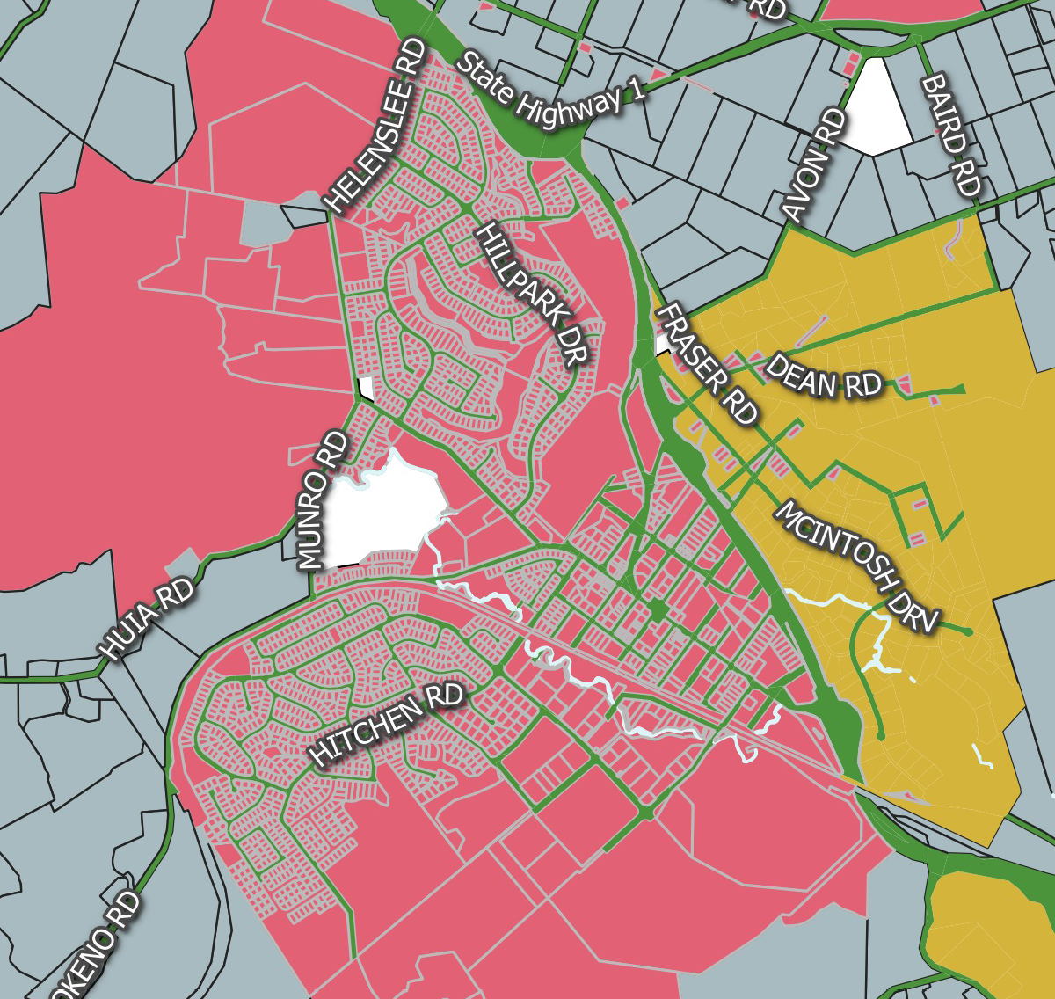
Option 3: District Plan zones only – Recommended by staff (Attachment 5)
Use a combination of District Plan zones for the purposes of the Bylaw.

Staff note the at the first workshop Council expressed reservations about using District Plan zones for the purposes of this Bylaw. This option has been included for comparison purposes. For example:

Urban area is defined as:
- Properties designated under the following zones as outlined in the Proposed District Plan; and
  - General residential zone
  - Medium density residential zone
  - Medium density residential zone
  - Local centre zone
  - Commercial zone
  - Town centre zone
  - General industrial zone
  - Heavy industrial zone
  - Business Tamahere zone
  - Matangi zone
  - Rangitahi peninsula zone

Lifestyle area: Properties designated under the following zones from the Proposed District Plan:
- Rural lifestyle zone
- Large lot residential zone
- Settlement zone
- KLZ Kimihia Lakes zone
- TaTa Valley zone

Rural area: Properties designated under the following zones from the Proposed District Plan:
- General rural zone
- Future urban zone
- Hopuhopu zone

Unspecified: The following zones are not considered to be located within a Rural, Urban or Lifestyle Area.
- Open space zone
- Correction zone
- Mercer airport zone
- Te Kowhai Airpark zone
- Motorsport and recreation zone

Advantages | Disadvantages
- The primary advantage of this approach is that the Bylaw aligns with the PDP.  - The PDP includes rules for where farming or intensive farming can occur. The Bylaw also includes rules for where animals can be kept. This means there is cross over as both documents manage where farm animals can be kept.  - If the Bylaw does not define urban/rural/lifestyle areas according to PDP zones, the bylaw will contradict the PDP rules for some properties.  - This is the preferred approach by Legal and Monitoring staff due to ease of identifying properties for enforcement purposes and consistency across documents. | - Using district plan zones only means some properties zoned as General Rural do not always function effectively as rural in practice. For example, properties zoned as General Rural located in Huntly function effectively as urban in practice.  - Smaller village properties within the Waikato are not captured as urban under the PDP and are therefore would not have rules in place to manage nuisance.  - Council can consider different factors (such as nuisance) when developing a bylaw compared to a PDP. As such, aligning the Bylaw with PDP zones may not achieve the purpose of the Bylaw. The purpose of the Bylaw is to manage animal nuisance, enabled by the LGA. In comparison, the purpose of the PDP is to manage and promote the sustainable management of natural and physical resources, enabled by the Resource Management Act 1991.

Figure 3: Map of Pookeno, Option 3: Proposed District Plan zones. Urban properties are coloured red, lifestyle properties are yellow, and rural properties are grey. Areas which are not categorised as urban, lifestyle, or rural areas are white.
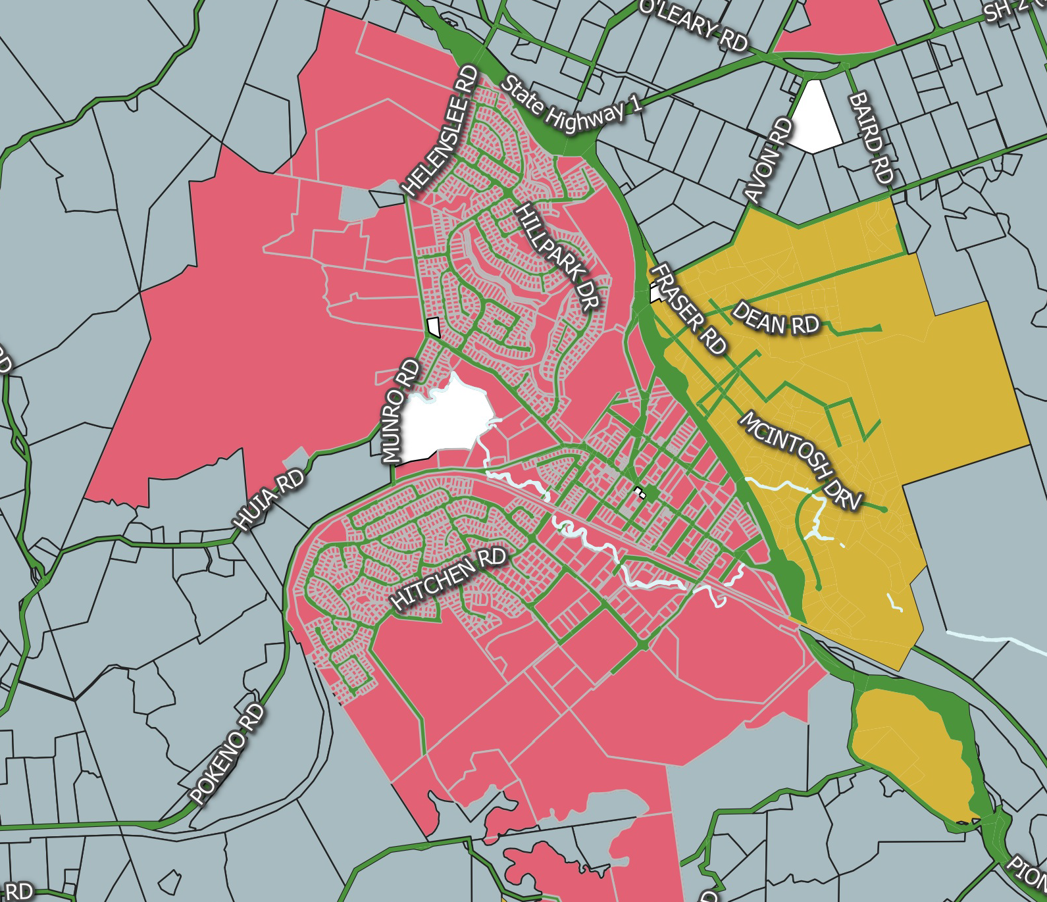
Option 4:
Use bespoke maps, attached to the Bylaw as appendices, to define the areas in the district.

Advantages | Disadvantages
- Highly accessible, visual tool to show the boundaries of the rules’ application. | - Difficulty implementing any future changes as new development occurs across the district. New maps would need to be created, or the Bylaw would be out of date.  - Extensive staff time to develop bespoke maps and provide sound justification for the entire district.  - Practical challenges for Council enforcement staff, who would be required to use pdf maps to identify where a property sits.

Pre-engagement with the community
It is proposed to undertake pre-engagement with the community, from 19 February to 31 March 2024. Pre-engagement will include an online survey and information (Attachment 2) and the previous version of the 2015 Bylaw (Attachment 6). The following stakeholders will be contacted and invited to provide feedback through the online survey:
- Groups and businesses involved with animals.
- Community boards and committees.
- Mana whenua.
- Previous submitters from the 2015 (amended in 2021) Bylaw.
Planned external communications include a media release, social media posts and Council’s newsletter, posters to be displayed in offices, libraries and vet clinics.

The online page will include the following questions listed below. Please note question 3 and 4 will be amended if required, to reflect Council’s decision on an approach to defining rural, lifestyle and urban areas.

- Have you or your organisation experienced animal (excluding dogs) nuisance in the Waikato district?
- If yes, please share details about the type of nuisance you experienced – such as noise, roaming and odours from animals. Your insight will help us better understand and address these issues effectively in the proposed Bylaw.
- Do you believe roosters should be allowed to be kept in lifestyle areas in the Waikato district? Lifestyle areas are defined as properties with a land area of 2,500 square metres to 15,000 square metres. Please tell us why.
- We are considering using property size to define the terms “urban,” “lifestyle” and “rural”, for the purposes of this Bylaw. Do you support this approach? Please tell us why.
- What type of bird/s do you believe should be included in the definition of poultry and why?
- What is your preferred limit for the number of poultry (including chickens but not roosters) you would be comfortable allowing in our urban areas?
- Please include any additional comments or suggested changes to the Bylaw.

Timeframes
Date | Action
21 November 2023 | First workshop with Council.
13 February 2024 | Second workshop with Council.
19 February to 31 March 2024 | Six-week pre-engagement period with community and stakeholders.
May 2024 | Third workshop with Council, reporting results of pre-engagement and seeking further changes to proposed bylaw.
18 June 2024 | Policy and Regulatory Committee, to seek approval to consult.
June / July 2024 | Formal consultation.
September 2024 | Hearings and deliberations.
December 2024 | Adoption of the Keeping of Animals Bylaw 2024.

Attachments

- Proposed Keeping of Animals Bylaw 2024.
- Pre-engagement material and survey.
- Option 1: Maps of property sizes.
- Option 2: Maps of combination of property size and zones.
- Option 3: Maps of district plans zones only
- Keeping of Animals Bylaw 2015 (amended in 2021).

